Stewart’s Theorem

Stewart’s Theorem, though outside the Hong Kong Exam syllabus, is one of the important theorems in geometry. It is not too difficult to learn. See whether you can manage.

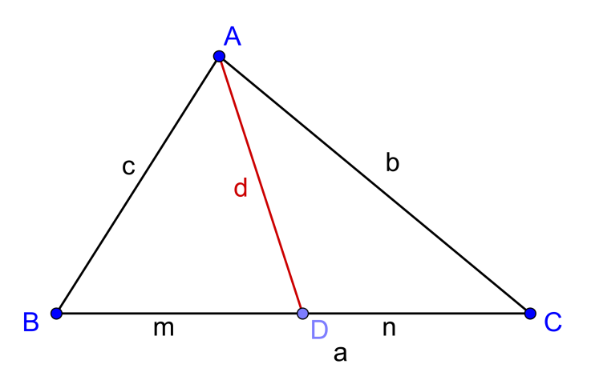

Given any triangle $ABC$. $AD$ is any arbitrary line. The base of the triangle: $a=m+n$.
(a) Prove Stewart’s Theorem: $b^{2}m+c^{2}n=a\left(d^{2}+mn\right)$ by:
(i) Pythagoras Theorem
(ii) using trigonometry.

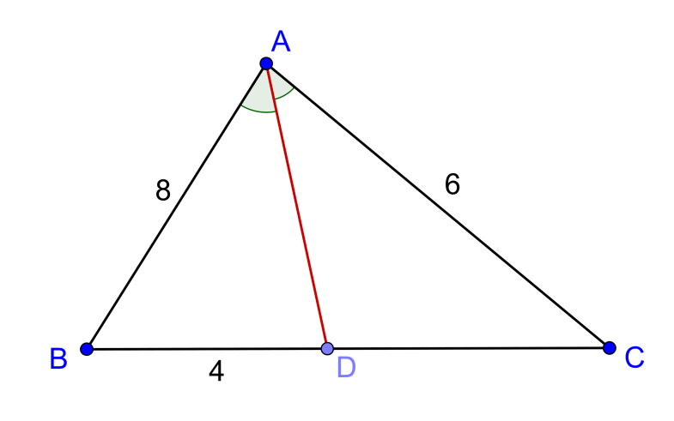
(b)
In the diagram on the right,
$AD$ bisects $∠BAC$ .
$AB=8, AC=6, BD=4,$
Find the length of $AD$ .

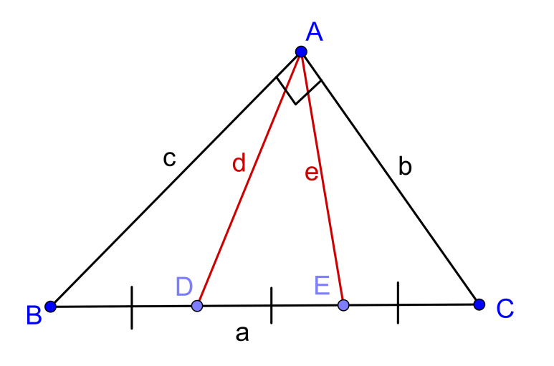
(c) Prove that the sum of the square of the distances from the vertex of the right angle, in a right angled triangle, to the trisection point of the hypotenuse, is equal to $\frac{5}{9}$ the length of the hypotenuse:

$d^{2}+e^{2}=\frac{5}{9}a^{2}$

(a) (i) Draw a perpendicular line $AE$ from $A$ to $BC$ .
Let $AE=h, ED=x,BE=m-x$

Then:
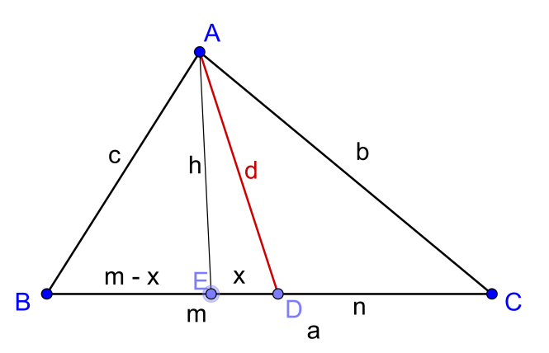
$b^{2}=h^{2}+{\left(n+x\right)}^{2} ….(1)$
$c^{2}=h^{2}+{\left(m-x\right)}^{2} ….(2)$
$d^{2}=h^{2}+x^{2} ….(3)$

$\left(1\right)-\left(3\right), b^{2}-d^{2}=n^{2}+2nx ….(4)$
$\left(2\right)-\left(3\right), c^{2}-d^{2}=m^{2}-2mx ….(5)$

$\left(4\right)×m,$ $b^{2}m-d^{2}m=n^{2}m+2mnx ….(6)$
$\left(5\right)×m,$ $c^{2}n-d^{2}n =m^{2}n-2mnx ….(7)$

$\left(6\right)+\left(7\right),$ $b^{2}m+c^{2}n-d^{2}\left(m+n\right)=mn\left(m+n\right)$
$b^{2}m+c^{2}n-{ad}^{2}=amn$
$b^{2}m+c^{2}n=a\left(d^{2}+mn\right)$

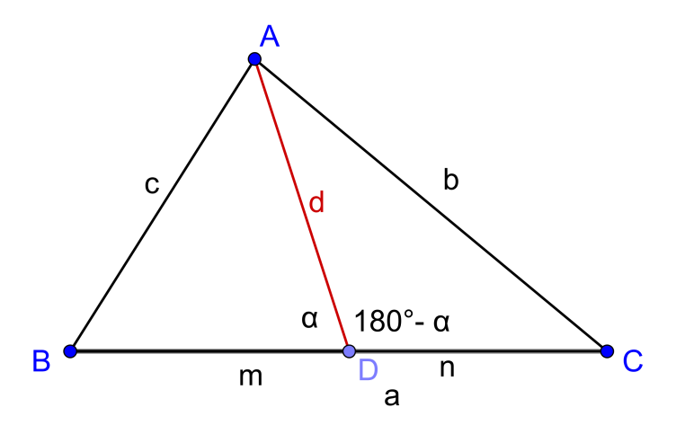
(ii) Let $∠ADB=α,∠ADC=180°-α$

By Cosine Law,
$\cos{α=\frac{m^{2}+d^{2}{-c}^{2}}{2md}} ….(1)$
$\cos\left(180°-α\right)=\frac{n^{2}+d^{2}{-b}^{2}}{2nd}$
$-cos α{=\frac{n^{2}+d^{2}{-b}^{2}}{2nd}} ….(2)$

$\frac{m^{2}+d^{2}{-c}^{2}}{2md}=-\frac{n^{2}+d^{2}{-b}^{2}}{2nd}$
$-m\left(n^{2}+d^{2}{-b}^{2}\right)=n\left(m^{2}+d^{2}{-c}^{2}\right)$

Rearrange and putting $a=m+n,$ we have
$b^{2}m+c^{2}n=a\left(d^{2}+mn\right)$

Stewart’s Theorem can be re-written in the form:
$man+dad=bmb+cnc$ . (Mnemonic : A man and his dad put a bomb in the sink.)

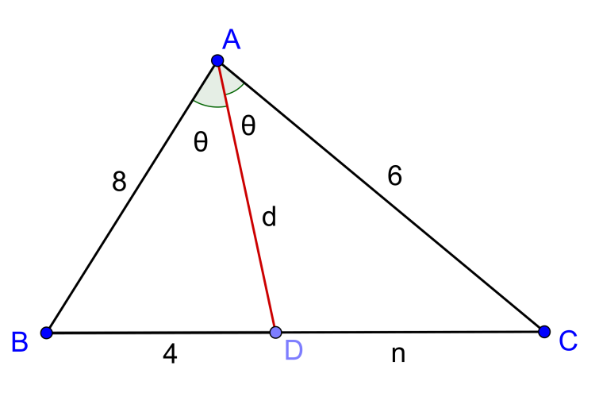
(b) Let $∠BAD=∠CAD=θ$
Since
$\frac{Area of ∆ABD}{Area of ∆ACD}=\frac{4}{n}$
$\frac{\frac{1}{2}×8dsin θ}{\frac{1}{2}×6dsin θ}=\frac{4}{n}$
$∴n=3$
(This is angle bisector theorem: $\frac{8}{6}=\frac{4}{n}$ . )

By Stewart’s Theorem
$b^{2}m+c^{2}n=a\left(d^{2}+mn\right)$
$6^{2}\left(4\right)+8^{2}\left(3\right)=7\left(d^{2}+4×3\right)$
$∴d=6$ (Taking positive root.)

(c) Apply Stewart theorem to $∆ABC$ in two ways, using $AD$ and $AE$ as the lines of cutting the triangle: $\left\{\begin{aligned}c^{2}\left(\frac{2}{3}a\right)+b^{2}\left(\frac{1}{3}a\right)=a\left[d^{2}+\left(\frac{2}{3}a\right)\left(\frac{1}{3}a\right)\right] \\ c^{2}\left(\frac{1}{3}a\right)+b^{2}\left(\frac{2}{3}a\right)=a\left[e^{2}+\left(\frac{2}{3}a\right)\left(\frac{1}{3}a\right)\right]\end{aligned}\right.$

$\left\{\begin{aligned}c^{2}\left(\frac{2}{3}\right)+b^{2}\left(\frac{1}{3}\right)=d^{2}+\left(\frac{2}{3}a\right)\left(\frac{1}{3}a\right) \\ c^{2}\left(\frac{1}{3}\right)+b^{2}\left(\frac{2}{3}\right)=e^{2}+\left(\frac{2}{3}a\right)\left(\frac{1}{3}a\right)\end{aligned}\right.$

Adding, we have $c^{2}+b^{2}=d^{2}+e^{2}+{\frac{4}{9}a}^{2}$
By Pythagoras Theorem, $a^{2}=d^{2}+e^{2}+{\frac{4}{9}a}^{2}$
${∴ d}^{2}+e^{2}=\frac{5}{9}a^{2}$

Yue Kwok Choy
19/8/2016

